Throughout the year NEMRC receives a number of calls asking for assistance to resolve various issues in relation to parcels in their grand list.

One of the first reports we recommend that you be comfortable with is the 411 report found on the ‘Reports Menu’ This report is broken down into sections and only includes Active and Taxable parcels. This is a nice report to identify how many parcels you have that are enrolled in Current use or have Veterans Exemptions, or Voted Exemptions. It’s a great tool for seeing how many personal property records you have on your grand list. You can also figure out what percentage of your assessed values are categorized as Homestead vs Non Residential.
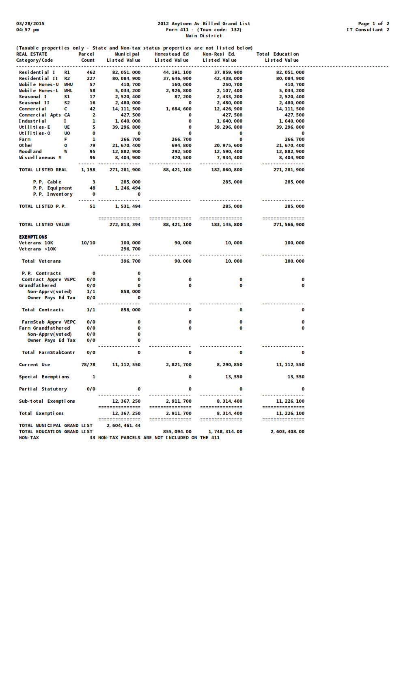

All Taxable & Active Parcels broken down by category.

All Personal Property Accounts

All Exemptions

Total Grand Lists Values

Property owners and tax bill / Homestead questions. A Property owner contacts the town and has questions about their tax bill. It appears they are being taxed as a Non Resident. How would you handle this inquiry?

- Get the Parcel ID, Span number, or Owner name and address.
- Open the As billed Grand List
- Go to the Reports menu and preview a ‘Copy of their original tax bill’ or you can also use the ‘Original Tax Book’ report.
- Followed by a ‘Adjusted/Revised bill’ or ‘Current Tax book’ to make sure the parcel hasn’t been updated already and the owner just hasn’t received a new tax bill yet.
- If these reports show they are being taxed as a non resident dig a little deeper.
- Are they being taxed partially as a Resident and partially non resident? If so check to see if they declared business / Rental use on their Homestead Declaration.
- Is the Homestead and house site value missing from their parcel. Look at their record using ‘1 Parcel Maintenance’ or ‘5 Parcel Display’ Below I can see there is both Homestead and Non Residential values on this parcel.
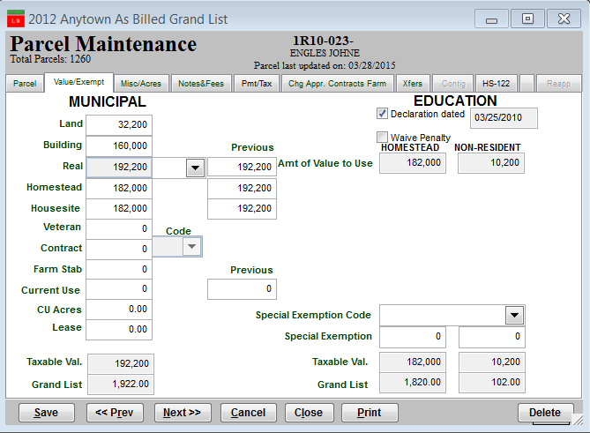

- Proceed to the ‘HS-122’ tab and review their Declaration. This tab will show you if they declared business/rental use, when/if they filed and how many times they filed. In this example they should not have any non residential tax applied to their property so the Homestead and Housesite values need to be adjusted by the Listers/Assessors accordingly. Then the property owner will get a revised tax bill.
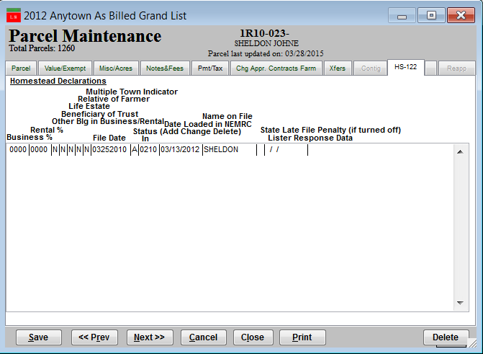

Other common question NEMRC Support receives often is “I want a list of all parcels sorted by”:
- Street
- City
- Owner Name
- Taxes
- The list goes on and on….

For these requests we recommend using ‘H Export Data’ this option gives the end user the flexibility to select which fields they want to see listed and export them to excel. Once in Excel they can sort on any field they desire. Note that some more complex reports may require the assistance of NEMRC support but for the most part this option will prove very valuable. Once you have the data sorted in the order you are looking for you can remove the parcels in the list you do not want.
Another request we get is for mailing labels for a specific street or area in town. This can be done using ‘A Mailing / Lister Card Labels’ on the Reports Menu. With this type of request we might use the ‘Foxpro Expression’ feature. This feature allows you to ‘Filter out your data’ For example: If we want labels for all records that have a category of ‘R1’. The expression we would enter is:
P_cd2 = ‘R1’

Refer to the help document on line at http://www.nemrc.com/support/ and click the link labeled ‘Fox Pro Expressions’. For additional assistance call NEMRC support.

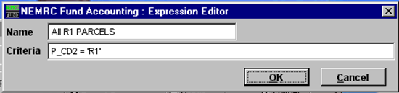
Click on the drop down button to select an expression you created earlier.
Type your FoxPro expression here.
Click the Ok button to save your FoxPro expression for future use.
Give the expression a name that will describe the output. You can name it anything you would like.

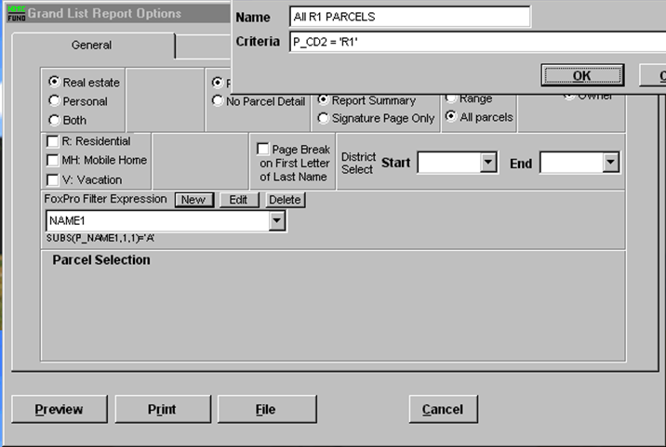
Click on theses buttons

New - create an expression.
Edit - modify an existing expression.
Delete - remove an existing expression.

ZIP CODE S 05701
REAL VALUES > 75,000
LAST UPDATED

